**How to start battle field 2042**

1. Go to C:\Users\Ratsucksatmath\Desktop\ahk
2. Run “ahi uninstall.bat”
3. Now disable “2.2 - AHI Template 2.0.ahk” in the icon tray
4. Restart your pc

**How to clean up after playing battlefield 2042**

1. Go to C:\Users\Ratsucksatmath\Desktop\ahk
2. Run “ahi install.bat”
3. Open “AutoHotInterception” folder
4. Restart your pc
5. Next we will need the pid and vid codes for the numpad. Run Monitor.ahk (if it doesn’t open go to the lib folder and run Unblocker.ps1) <if windows 11 messes up the gui>
6. Unplug all of the unpluggable hid keyboards 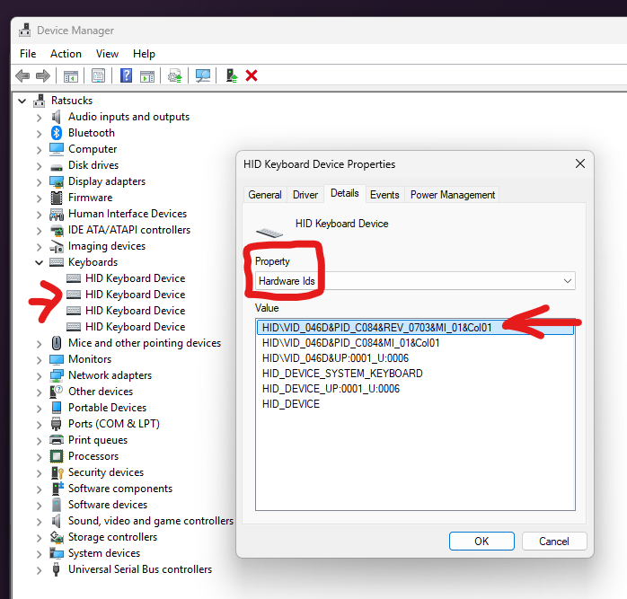

Write down these pid and vid codes for every hid device

1. Edit the “2.2 - AHI Template 2.0.ahk” file and locate the 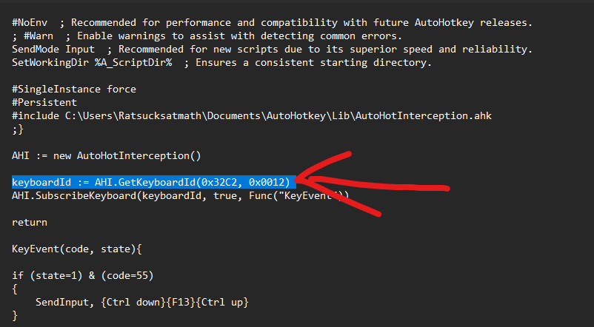

Vid and hid codes

1. Start A/B testing with all the written down vid and pid codes
2. Save the ahk file
3. restart your pc